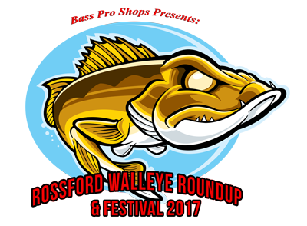
Bass Pro Shops Presents:
Rossford Walleye Roundup & Festival
in Rossford, Ohio on April 19 – April 21, 2018
Sponsorship Agreement

REGISTRATION

BUSINESS NAME__________________________________________________________

CONTACT PERSON ________________________________________________________

BUSINESS ADDRESS _______________________________________________________

CITY ________________________________ STATE _______ ZIP CODE ______________

PHONE _____________________ E-MAIL ADDRESS _____________________________

WEBSITE ADDRESS (if applicable) ____________________________________________

PACKAGES – See attached letter and package descriptions. Check your desired sponsorship level.

#1 – “Gold Sponsor” - $500* ____________
#2 – Big Fish Purse - $1,000 ____________
#3 – Largest 1-Day Bag Weight - $750 ____________
#4 – “Silver Sponsor” - $250 ____________

SIGNATURE _________________________________ DATE ___________________

Print and return registration form to: Rossford Convention & Visitors Bureau, 1001 Dixie Hwy., Suite D, Rossford, Ohio 43460. Checks should be made payable to Rossford Walleye Roundup & Festival. Contact Beth Genson at 419-308-7530 or by email at bethgenson@visitrossfordohio.com for more details.

Sponsorship is limited and available on a first-come, first-served basis and no later than January 31, 2018 to take advantage of all opportunities. *Gold, Big Purse, and Largest 1-Day Bag Weight sponsors must submit their logo in a AI or TIF formats to: bethgenson@visitrossfordohio.com

